For 17.2.23
Group A
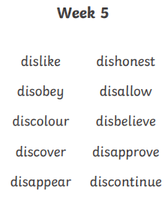
Spellings week beginning 13.2.23
For 17.2.23
Group B
work
that’s
baby
gave
mouse
something
still
found
live
night

For 17.2.23
Group C
take
thought
find
more
I’ll
round
magic
shouted
other
through

For 17.2.23
Group D
sort
snort
short
sport
fork
are
my
her
what
there

