For 17.3.23
Group A
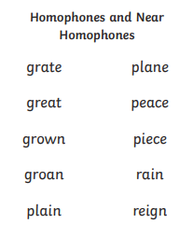
Spellings week beginning 13.3.23
For 17.3.23
Group B
laughed
would
again
wanted
everyone
thought
through
something
couldn’t
these

For 17.3.23
Group C
gave
mouse
something
found
live
night
narrator
small
couldn’t
head

For 17.3.23
Group D
fair
chair
stair
lair
hair
like
some
so
then
were

