For 24.3.23
Group A
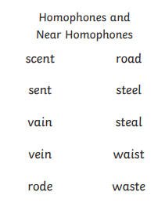
Spellings week beginning 20.3.23
For 24.3.23
Group B
water
want
Were
where
hear
here
there
their
thought
through

For 24.3.23
Group C
king
town
I’ve
around
every
garden
fast
only
many
laughed

For 24.3.23
Group D
eat
tea
real
clean
steal
go
little
as
one
them

