For 27.1.23
Group A
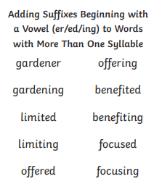
Spellings week beginning 28.10.22
For 27.1.23
Group B
water
want
over
where
would
school
home
who
didn’t
know

For 27.1.23
Group C
water
away
good
want
over
how
did
man
going
where

For 27.1.23
Group D
park
shark
park
spark
start
mark
the
to
said
of

