For 17.2.23
Group A
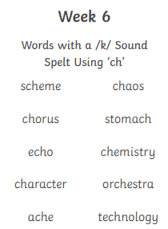
Spellings week beginning 27.2.23
For 17.2.23
Group B
narrator
couldn’t
head
I’ve
around
every
only
laughed
garden
many

For 17.2.23
Group C
door
right
sea
these
began
animals
never
first
work
that’s

For 17.2.23
Group D
girl
bird
third
dirt
thirsty
out
this
have
went
be

