For 3.2.23
Group A
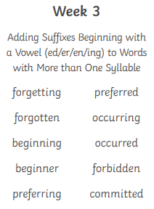
Spellings week beginning 30.1.23
For 3.2.23
Group B
bear
can’t
again
new
after
wanted
everyone
our
two
thought

For 3.2.23
Group C
would
took
school
think
home
who
didn’t
know
bear
can’t

For 3.2.23
Group D
out
shout
found
round
mouth
was
you
they
she
for

