For 10.2.23
Group A
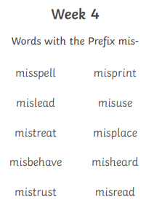
Spellings week beginning 6.2.23
For 10.2.23
Group B
magic
shouted
other
through
door
right
sea
these
animals
first

For 10.2.23
Group C
again
long
things
new
after
wanted
eat
everyone
our
two

For 10.2.23
Group D
toy
boy
enjoy
ploy
his
but
that
with
all
we

